ANZ FXIP Client Onboarding –

Dual Verify Client Setup

Applicable to
Australia & New Zealand only

Description
The purpose of this process is to outline the steps taken in setting up a new Client in FXOPS/GEMM – based on the information left on the Client page in Salesforce.

Additional systems and tool
- Access to Salesforce
- Access to FXOPS/GEMM for Australia & New Zealand markets
- Access to website http://bsb.apca.com.au/ to validate bank address for settlement method
- Notes pad with notes from validation stage

Steps
- Log into FXOPS/ GEMM
- Select relevant market (i.e.: AU/NZ) from dropdown menu
- Click on System access

- Click on Approve
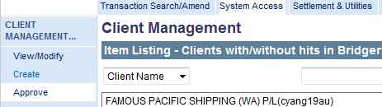

- Locate the the Client requiring Dual Verification & Approval.
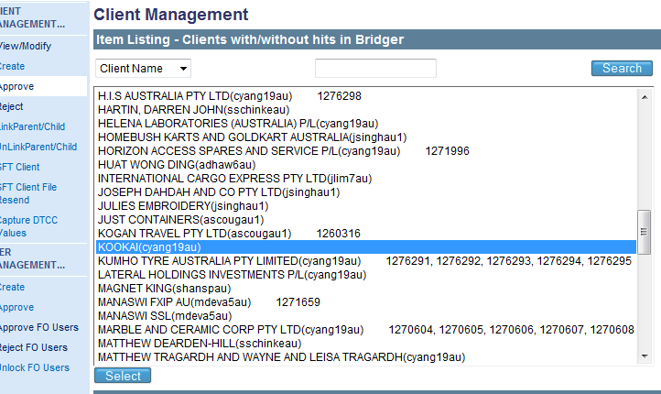
- Click Select
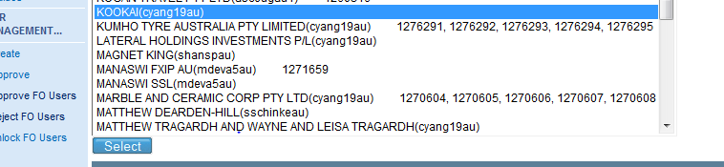
- Click Continue at the bottom of ‘Summary of Changes’ page
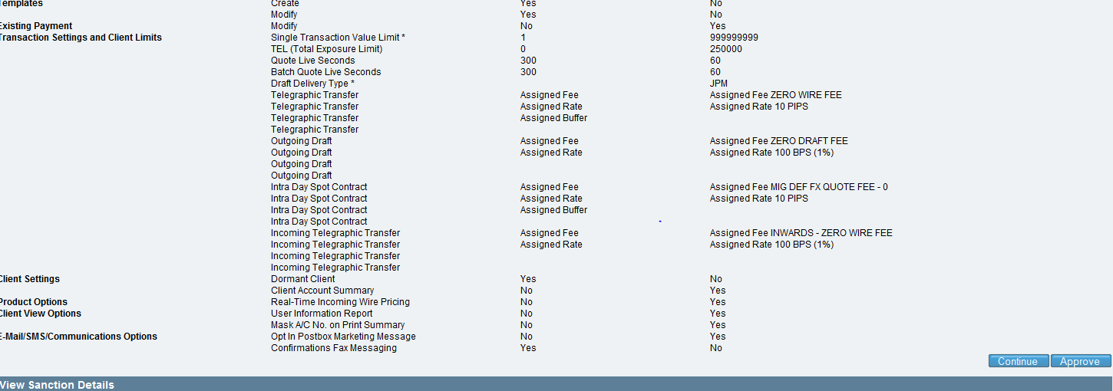
- Verify the ‘Client Name in Transaction System’ in SFDC

- Verify the same has been inputted into ‘Client Trading Name* & Group’ in FXOPS.
Note:Drop down [N/A] auto populates

- Verify client status
If | Then
If call out is pending | Must have selected “deactivate”
If call out has been made | Must have selected “Active”

- Move to the following page, and verify KYC Settings, except where noted*
FIELD | SELECT
Major SIC Code | -10-Unknown
Minor SIC Code | -10-Unknown
Major ANZIC Code | Check industry code from ANZSIC Code Detail Spreadsheet
Minor ANZSIC Code | Check industry code from ANZSIC Code Detail spreadsheet
Business Type | Check ‘Legal Entity Type’ in KYC Database Record.
Identification Of Client | *Auto populates
Account Manager User | Check correct Account Manager has been selected, verifying from ‘Client Owner’ field on client page.
Payment Requirement Type | Supplier Payments
Membership Rewards Point Ratio | 1:30
Forecast Monthly Transaction value | *Auto populates
Date of Birth | *Auto populates
Lead Source | Cold Calling
Internal Business Segment Type | Sales
Relationship Manager | *Auto populates
Forecast Monthly Transactions | *Auto populates ( sync)
Example:
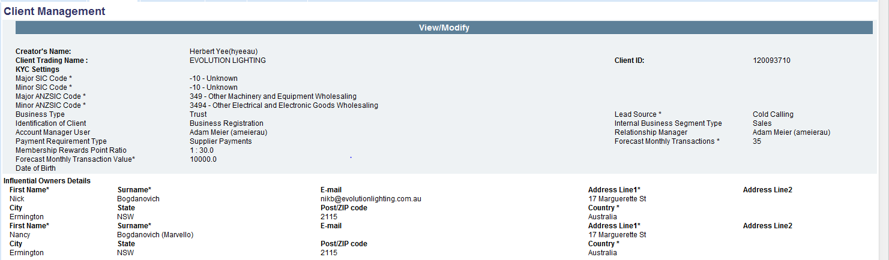
Note: Influential Owners Details auto populate
- Verify Client information for MR Points
Field | Action
First name | Verify client’s name
Surname | Verify client surname
Enroll In MR | Must be ticked
Enroll IP MR | Must be ticked
Amex Card Number | Verify against application form
Card Type | Corporate
Percentage Split | 100% – 1 card member  50% each – 2 card members (Note: click on “Add” to keep adding card members)

- Scroll down and verify if client has been set up for Access Line

If | Then
Access Line has been set up | Verify set up is “Same Day Value”
Access Line has NOT been set up | No action required. Continue validating.

- Client Security Settings will autopopulate.
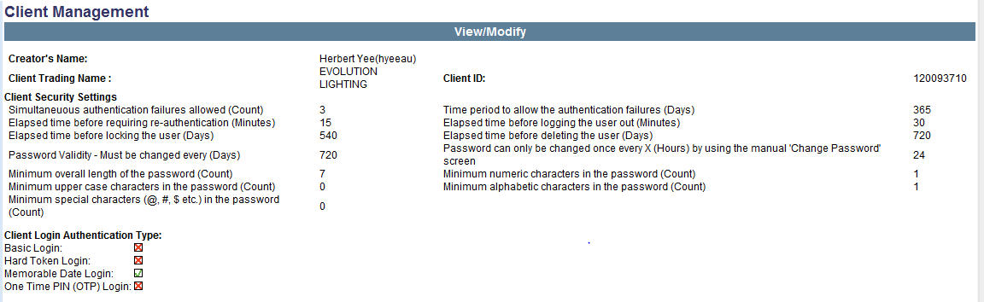
- Verify BPAY facility has been added.
BPAY | Tick ‘ACT’ option and select Bpay from drop down menu

- Verify Bank details if applicable. Bank details must be correct as per support in SFDC.
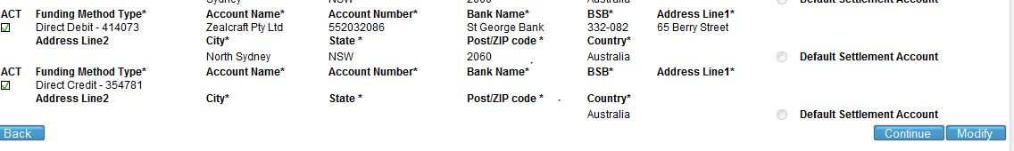
- Click “Continue”
- Verify account settings as per information on Salesforce or application:
FIELD | VERIFY
Creator's Name | Auto Populates
Client ID | Auto Populates
Buffer Schedule | Auto Populates
Real Time Incoming Wire | Ticked if bank account supplied
Draft Delivery Type  (only if selected on Application) | JPM selected
Foreign Collection Counterparty | JPM selected
FIELD | Create | Modify | Dual Verify  Level 1 required | Dual Verify  Level 2 required
Telegraphic Transfer (TT) | Ticked | Ticked | Ticked if Dual Verification was selected on application form | Ticked if a Dual Verification 2 was selected on case notes or sensitive contact
Outgoing Draft  (only if selected on Application) | Ticked | Ticked | Ticked if Dual Verification was selected on application form | Ticked if a Dual Verification 2 was selected on case notes or sensitive contact
Outgoing Forward Contract (FEC) | Ticked if approved for FEC | Ticked if approved for FEC | NA | NA
Intra Day Spot Contract | Ticked | UNTICK | NA | NA
Incoming Telegraphic Transfer | Ticked if bank account supplied | NA | NA | NA
Incoming Forward Contract | Ticked if approved for FEC/bank account supplied | NA | NA | NA
Payment Scheduling | Auto populates | Auto populates | NA | NA
Payment Scheduling – Reoccurring | Auto populates | Auto populates
Incoming Draft | NA | NA | NA | NA
Cross Border ACH | NA | NA | NA | NA
Payees | Auto populates | Auto populates | NA | NA
Templates | NA | NA | NA | NA
User Administration | Ticked | Ticked | NA | NA
Create Rate Alert | Ticked | NA | NA | NA
Cross Currency Outgoing Wire | Ticked if selected | Ticked if selected | Tick if Dual Verification was selected on application form | Tick if a Dual Verification 2 was selected on case notes or sensitive contact
Cross Currency Outgoing Draft  (only if selected on Application) | NA | NA | NA | NA
Like for Like Outgoing Wire | Ticked if selected | Ticked if selected | Ticked if Dual Verification was selected on application form | Ticked if a Dual Verification 2 was selected on case notes or sensitive contact
Like for Like Outgoing Draft | Ticked if selected | Ticked if selected | Ticked if Dual Verification was selected on application form | Ticked if a Dual Verification 2 was selected on case notes or sensitive contact
Existing Payment | Ticked | Ticked | NA | NA
Single Transaction Value limit | Auto populates
TEL (total Exposure Limit) | Auto populates (check against case notes)
Rolling Transaction Limit | Auto populates
Single Transaction limit | Auto populates
Create Default Ordering Customer | Ticked
Ordering Customer FO Lock Down | NA
Create default Originating Payer | Ticked (if Incomings)
Amex Location | Do not tick
Quote Live Seconds | As per slab
Batch Quote Live Seconds | As per slab
Client Payee Correspondent Charges | NA
Rate Type* | Auto populates
Linear Pricing | NA
Boost | NA
Example:
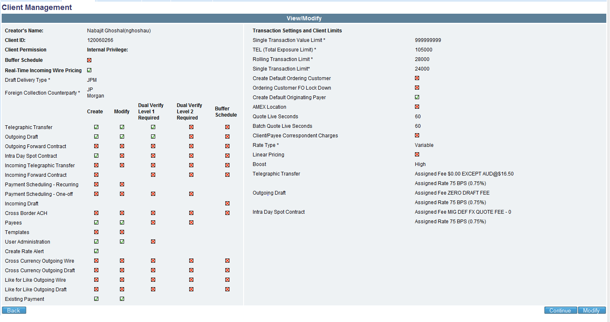
- Verify assigned fees in FXIP GEMM match ‘Client Pricing’ information from Salesforce.
Client Pricing | FXIP GEMM Assigned Fee
eCIL TT Rate | Telegraphic Transfer assigned rate
eCIL TT Fee | Telegraphic Transfer assigned fee
eCIL Forward Rate | Forward Exchange Contract assigned rate
ECIL Forward Fee | Forward Exchange Contract assigned fee
eCIL Draft Rate | Outgoing Draft assigned rate
eCIL Draft Fee | Outgoing Draft assigned fee
eCIL Incoming Rate | Incoming Telegraphic Transfer rate
eCIL Incoming Fee | Incoming Telegraphic Transfer fee

- For the following products, verify fees and rates against same information on ‘Client Pricing’ information from Salesforce:
Product | Assign fee/rate
Intra Day Spot Contract Rate | Verify against Telegraphic Transfer rate in Salesforce
Intra Day Spot Contract Fee | Check the following has been selected.  MIG DEF FX QUOTE-0
Cross Currency Rate | Verify against Telegraphic Transfer rate
Cross Currency Fee | Verify against Telegraphic Transfer fee
Like for like Fee | Verify against Telegraphic Transfer fee

- 15. Once verified, click continue
- 16. Verify client permissions as per Salesforce
FIELD | SELECT
Creator's Name | Auto Populates
Client Trading name | Auto Populates
Client ID | Auto Populates
Restricted Settlement Method | NA
Place client on watch | NA
Local currency transaction Via DBK | NA
TYPE DD Hold (DDH) | Ticked if specified in case notes
Allow Ops User Transact | 1. Check case notes to confirm if call out to verify application has been completed.  2. Ticked if completed.
Dormant Client | 1. Check case notes to confirm if call out to verify application has been completed.  2. Ticked if call out verification has not been completed.
Client Account Summary | Ticked
Batch Management | NA
Blended Transactions | Ticked
ByPass awaiting Funds | NA
Customer Forward Points | NA
DD bulk Client | NA
File Uploads | NA
Fix Forward Contract Drawdown Amount | NA
Fix Intra Day Spot Contract Drawdown Amount | NA
Force Spot + 1 Value | NA
Indicative Pricing Allowed (Formerly OOH) | Tick
International USD Payments Via JPM Charge | NA
Next Day Value | Ticked if client is has TEL
Overwrite File Upload Payee Information | NA
Same Day PAD | NA
Same Day Value | Ticked if client is Access Line approved
Settlement in File Upload | NA
Live Rates Dashboard | NA
Opt out of Marketing Messages | NA
Enable Hover Help on Fields | Tick
Audit Trails | Tick
Reports | Tick
Payment History | Tick
Batch History | NA
Contract History | Ticked if FEC has been approved
User Information Report | Ticked
Mask Account Number | Ticked
Opt In Postbox Marketing Message | Ticked
Inbox | Ticked
Confirmations Fax Messaging | NA
Client Notify-E-mail | Ticked
Client Notify-Postbox | Ticked
Approvers Notify-Email | Ticked only if set up as DV1 or DV2  ( Note: do not tick if single verification)
Missed Deal Email - to Account Manager | Ticked if account owner is:  - Charles Bradford  - Daniel V Zumstein  - Farhan Jiwani1  - Orla Waterman  - Rupal Mehta
CC Rate Alert to Account manager | Verify that tick is deleted

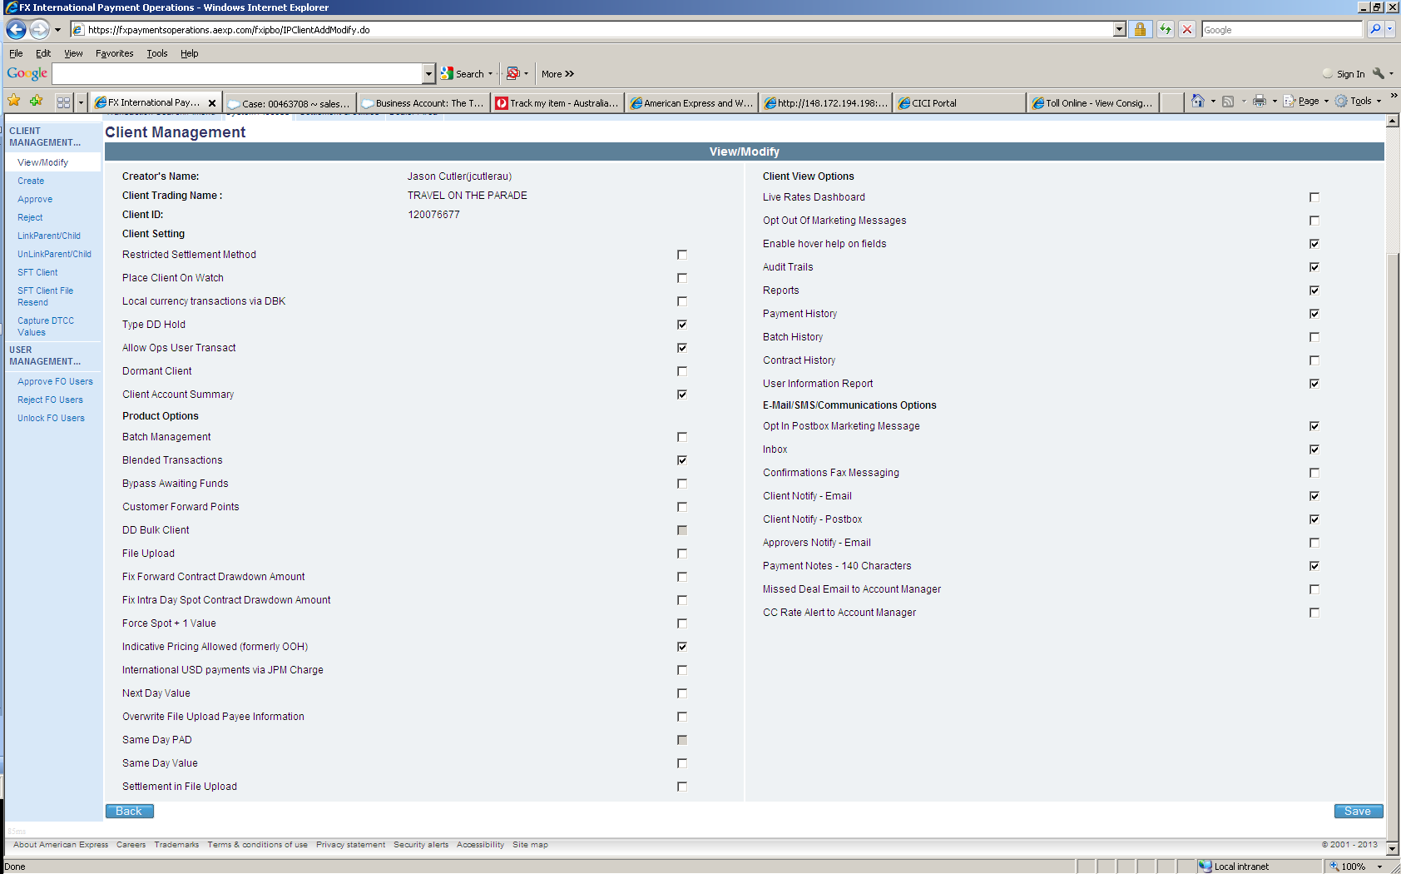
Example

- Return to Salesforce, Check Case Page/ case comments have been added as follows:
“Account set up completed. (Add settlement method). (Add information on TEL, FEC). Confirm if call out is pending. Awaiting DV
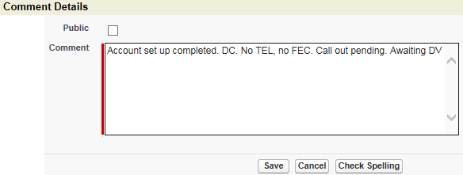
- Click ‘Approve’
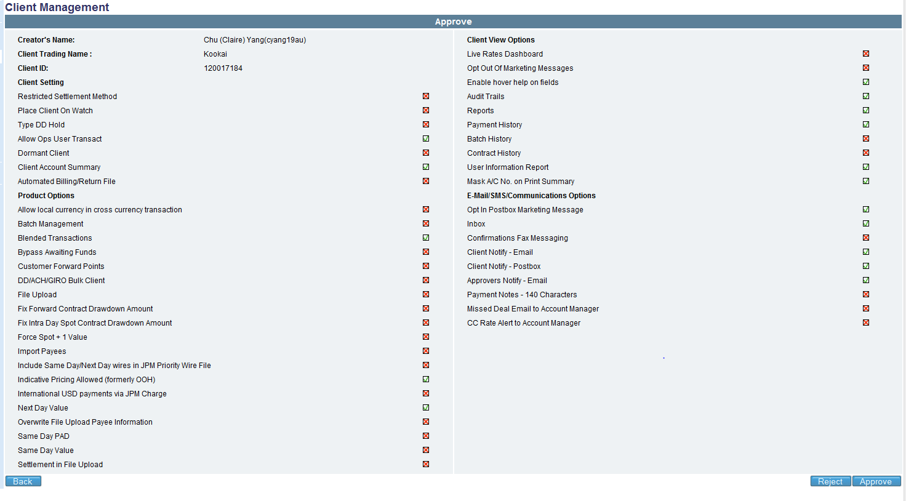
- Advise inputter of approval.

